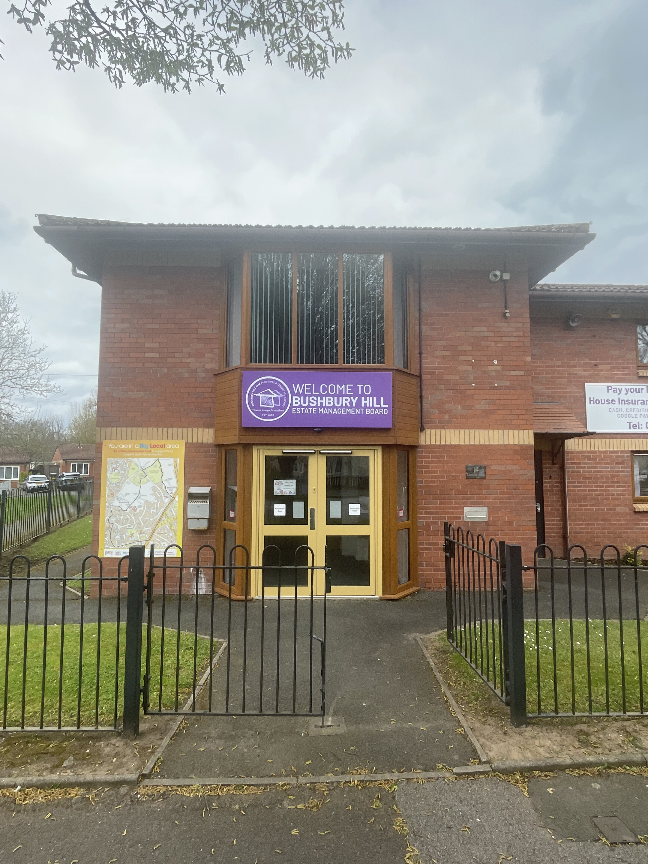  Lettable Standard  Bushbury Hill Estate Management Board | 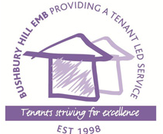

bUSHBURY

Bushbury Hill Estate Management Board (BHEMB) have agreed a lettable standard that empty properties must meet before they are let. This is a guide to give you (the new tenant) an idea of the minimum condition of property that has been allocated to you, set out in the specification below.
About your home: Much of the housing stock managed by BHEMB was built in the pre-war years (1920’s), with some constructed at later periods. Most of the properties were built using non-traditional construction methods (concrete), but some are brick-built properties
This document outlines the lettable standard for existing homes and not the first letting of a new build property. Mutual exchanges fall outside the scope of this standard, although many of the processes will apply to ensure that properties are safe and secure. Mutual exchange details can be located on Bushbury Hill Estate Management Board | Local Housing Service | Low Hill, Wolverhampton
BHEMB’s responsibilities: To provide you (the new tenant) with a home:
- To be safe, warm and of the required quality to be compliant with the latest legislative and regulatory standards.
- Will all certifications on sign up to confirm that all relevant work has taken place. Gas and Electrical checks, Energy Performance Certificates.
- With Smoke Alarms and Carbon Monoxide Alarms fitted and tested to be working.
- That is modern in terms of decent homes standard.
- That any outstanding repairs to the property that could pose a risk to health and safety will be identified and resolved before the property is let.
The new tenant’s responsibilities:
- Decoration: Your home may not be decorated to your personal taste when you move in, but it will be ready for you to decorate. BHEMB may provide redecoration vouchers when you move in, but it is your responsibility to decorate the property.
- Carpets/flooring: The kitchen and bathroom will be fitted with standard, non-slip vinyl flooring. BHEMB will not provide any floor covering to any other rooms.
- White goods and furniture: BHEMB will not provide any furnishings for your home as standard.
- Removal costs: BHEMB will not contribute towards any costs associated with moving home.
- Minor repairs & maintenance: You are responsible for the repair and maintenance of some items within your home. These items can be found in your Tenancy Agreement.
Kitchen
Kitchen units:
- All doors and drawers secure and fully operational
- All units and worktops should be clean, have tiled splashbacks, be sealed and free from damage.
- The number of kitchen units will depend upon size and layout of the kitchen.
Sink:
- Sinks to be clean and free of rust and stains with no leaks and free flowing waste. Plugs and chains to be secure.
- Taps to be drip free, identifiable as hot and cold, clean and easy to operate.
- Splash-back to be provided on the walls above the work surface and the sink to be secure, sealed around the work-top, secure and free from damage.
Cooker points:
- Gas: Capped off, ready for cooker to be fitted by a Gas Safe Engineer.
- Electric: power point installed ready for cooker to be fitted.
Plumbing:
- Washing machine spigot
- Valves and waste connections should be left ready to use.
- All piping free from leaks and isolation valves/stopcock identified to you on sign up.

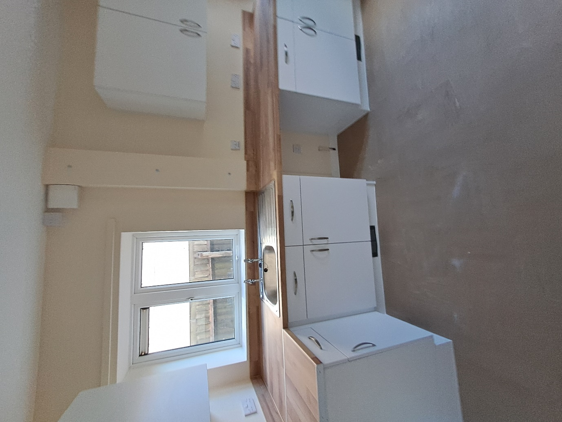

Unacceptable 
Acceptable

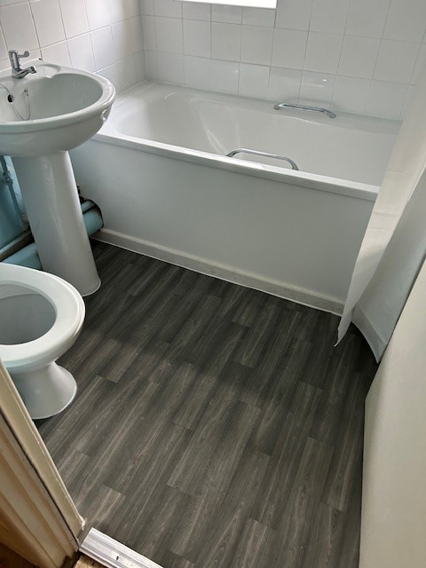

Bathroom/WC
Bath and shower:
- Clean and sealed where bath edges meet the tiling. Secure and free from chips. Plug and chain secure. Bath panel and frame secure and clean. No leaks, free flowing waste.
- New shower head and hose installed as part of void works.

Toilet pan/seat/cistern:
- Renewed seat
- Secure toilet pan
- Clean and easy to flush
Wash hand basin
- Secure and free from chips
- Plug and chain secure
- No leaks and free flowing waste
Taps
- Secure and clean
- Easy to operate
- Drip free and marked hot and cold, hot on the left, cold on the right.
Tiles
- Teo rows of tiles above wash hand basin and three rows above bath.
- Clean, intact, not loose or cracked and grouted.

Acceptable
Unacceptable

Staircase and handrails
- There will be at least one handrail per staircase. Handrails, steps, balustrades, Newell posts and treads to be securely fitted.
- The gaps between balustrades to be no wider than 100mm.
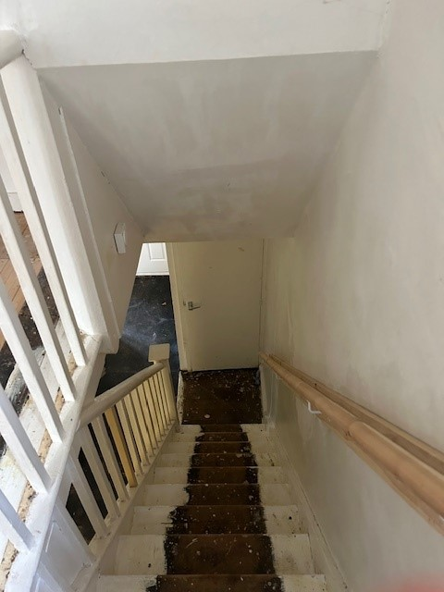

Unacceptable

Acceptable

Windows and doors
Doors
- All doors (internal and external) will be in good working order with the ability to open and close easily.
- New locks to be fitted to external doors as part of void works and 3 sets of keys supplied to new tenant.
Windows
- Security locks to be fitted to all non-egress windows and keys supplied to new tenant.
- Glazing to be intact, secure and free from damage.
- Windows will be easy to pen and close and safety catches operational.
- Window restrictors to be fitted to all windows that legislatively require them.

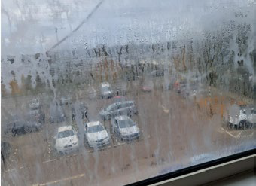
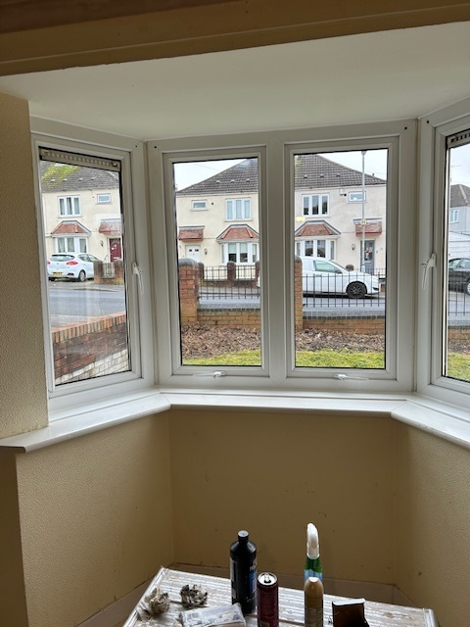

Acceptable
Unacceptable

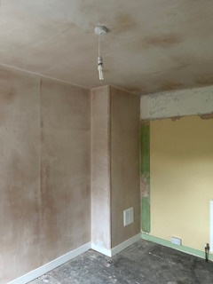
Walls and ceilings
Walls:
- To be in a sound condition, free from damp, mould, large cracks, loose/delaminated plaster and holes.
- Wallpaper to be left in good condition where possible.
Ceilings
- Polystyrene tiles removed from ceiling and surface made good.
- Free from mould and damp with surface ready for decoration.
- Angled junction of ceiling and wall in first floor rooms to be insulated where required.

Unacceptable
Acceptable

Gas
- The gas system will be tested and a copy of the Landlords Gas Safety Record Certificate will be provided.
- The boiler, radiators, thermostat and timer will be in good working order.
- Carbon monoxide detectors will be installed and checked as working.

Electric
- All electrical fittings will be tested to comply with the current safety regulations (NICEIC).
- All wiring, fuse boards, sockets, switches, heaters and light fittings to be in good working order.
- An electrical safety certificate will be provided and hard-wired smoke/heat alarms will be installed and checked as working.

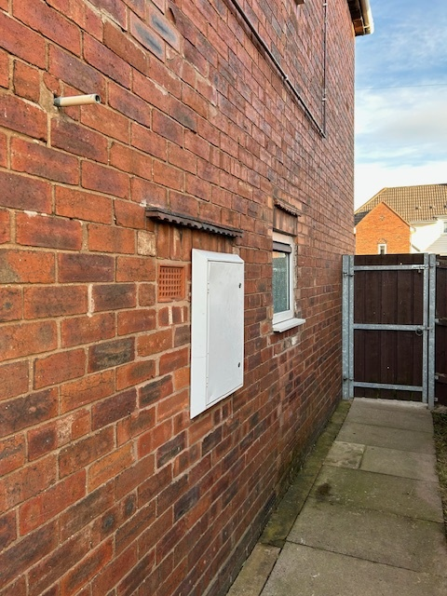

Unacceptable
Acceptable

Unacceptable
Acceptable

Outside space
Gardens
- Gardens and outside areas will be tidy, not overgrown and free from waste.
- Footpaths, ramps, eternal steps and driveways will be free from trip hazards.
- All non-standard structures will be removed, unless requested otherwise by incoming tenant and relevant paperwork signed.
- Fences and gates and boundary walls replaced or repaired to provide security.
- A clothesline, or rotary clothes dryer will be provided.
Building
- All rainwater goods fixed and connected.
- Drains and gulleys free from blockages with relevant covers in place.
- Roof will be watertight and free from defects.

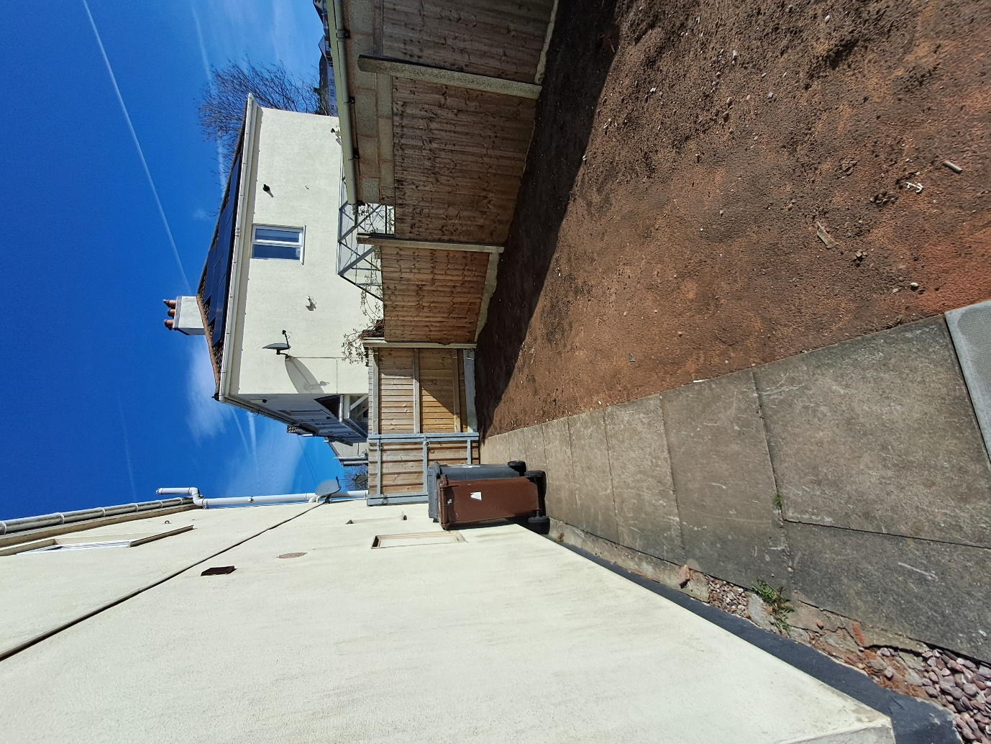

Unacceptable
Acceptable

Cleaning
- Properties will be in a clean and presentable condition.
- Windows will be cleaned internally.
- Kitchen worktops, units and floors will be cleaned.
- Sinks, toilets, baths and basins will be clean and disinfected.
- Property will be free from rubbish throughout.

Please take some time to read the lettable standards outlined in the document above and if you believe there is anything in your new home that does not meet these standards, you can report your concerns to
Email https://www.bushburyhill.co.uk/repairs/report-a-repair/
Telephone 01902 552995
A detailed breakdown of the lettable standard and associated processes can be found here Bushbury Hill Estate Management Board | Local Housing Service | Low Hill, Wolverhampton
Additional formats of the document – various languages, colours, contrasts and text sizes can be accessed via the Bushbury Hill Estate Management Board Website on https;//www.bushburyhill.co.uk following link Bushbury Hill Estate Management Board | Local Housing Service | Low Hill, Wolverhampton

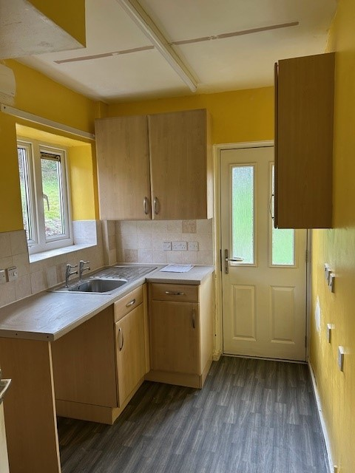

Unacceptable
Acceptable

